**WEEK 1**

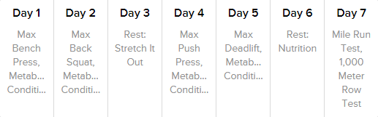

**WEEK 2**

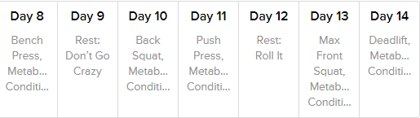

**WEEK 3**

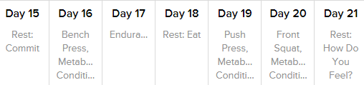

**WEEK 4**

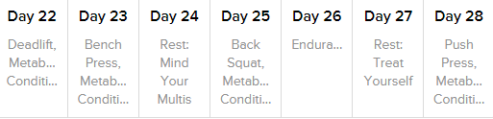

**WEEK 5**

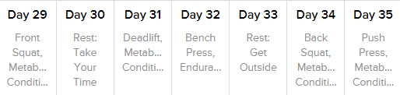

**WEEK 6**

